PIZZA SALES SQL QUERIES

1. KPI’S
2. Total Revenue :

Select Round(sum(total_price), 2) as Total_Revenue from pizza_sales_dup;

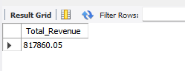

1. Average Order

Select sum(total_price) / count(distinct order_id) as Average_order from pizza_sales_dup;

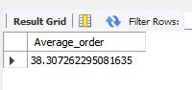

1. Total Pizza Sold

Select sum(quantity) as Total_Pizza_Sold from pizza_sales_dup;

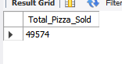

1. Total orders

Select count( distinct order_id) As Total_orders from pizza_sales_dup;

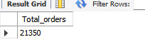

1. Average Pizza Sold per Order

Select sum(quantity) / count(distinct order_id) As Avg_Pizza_Sold from pizza_sales_dup;

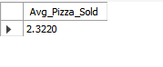

1. Percentage of Sales by Pizza category

Select pizza_category, Round(sum(total_price) *100 /

(Select sum(total_price)from pizza_sales_dup),2) as PCG_sales_pizza_category

from pizza_sales_dup

group by pizza_category;

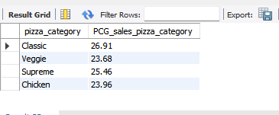

1. Percentage of Sales by Pizza size

Select pizza_size, Round(sum(total_price) * 100/ (Select sum(total_price) from pizza_sales_dup),2) as Pcg_sales_Pizza_size

from pizza_sales_dup

group by pizza_size;

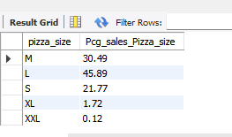

1. Total Pizza sold by Pizza category

Select pizza_category, Round(sum(quantity),2) as Total_quantity

from pizza_sales_dup

group by pizza_category;

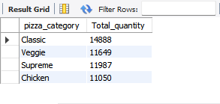

1. Top 5 Pizza sold

Select pizza_name, sum(quantity) as Rank_of_pizza

from pizza_sales_dup

group by pizza_name

order by Rank_of_pizza desc;

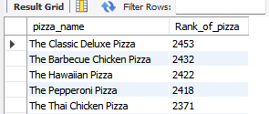

1. Bottom 5 Pizza sold

Select pizza_name, sum(quantity) as Rank_of_pizza

from pizza_sales_dup

group by pizza_name

order by Rank_of_pizza asc;

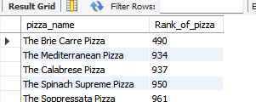

1. What hours has the least Pizza sold

select

hour(order_time) As order_hours,

count(distinct order_id) as Total_orders

from pizza_sales_dup

group by order_hours

order by total_orders;

